

**MATHEMATICAL METHODS**

**Units 3&4 – 2017**

**Written examination 1 Solutions**

**Question 1** (4 marks)

**a.** *y* = cos(*x*2 – 2) … using the chain rule

 **1A**

**b. i.** *f* (*x*) = *x*log*e*(2*x* – 5) … using the product rule and the chain rule

Let *u* = *x* ⇒ *u*′ = 1 **1M**

Let *v* = log*e*(2*x* – 5) ⇒ 



 **1A**

**ii.** 

 **1A**

**Question 2** (5 marks)

**a.** 

 **1A**

*f* (2) =  ⇒  **1M**



 **1A**

**b.** ** 1A**

** 1A**

**Question 3** (6 marks)

**a.** *D* = *R* \{2} **1A**

range = *R* \{−1} **1A**

**b.** *x* – intercept, let *y* = 0



3 = *x* – 2 ⇒ *x* = 5

*y* – intercept, let *x* = 0



(5, 0) and  **1A**

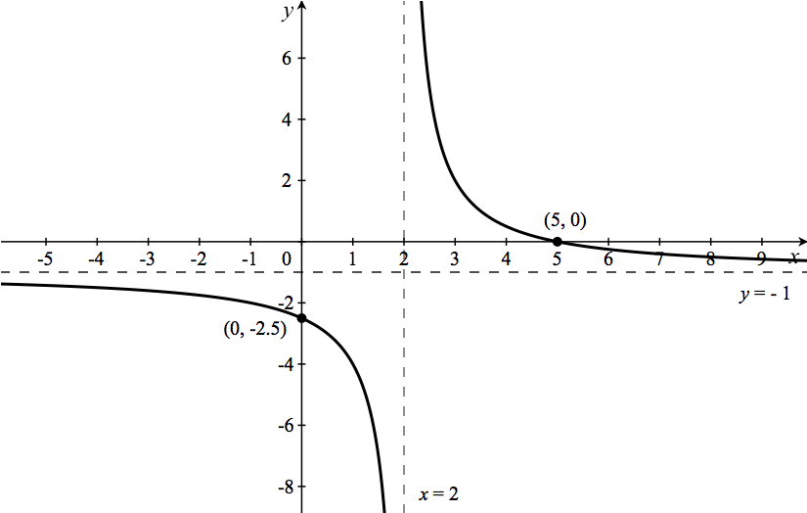 **1A**

**c.** 

 **1A**

** 1A**

**Question 4** (3 marks)

2log*e*(2*x*) − log*e*(2*x* – 1) = log*e*(3*x* + 1) … power law for logarithms

log*e*(2*x*)2 − log*e*(2*x* – 1) = log*e*(3*x* + 1) … subtraction law for logarithms **1M**



4*x*2 = (2*x* – 1)(3*x* + 1)

4*x*2 = 6*x*2 + 2*x* – 3*x* – 1

2*x*2 – *x* – 1 = 0 … factorise

(2*x* + 1)(*x* – 1) = 0

Using the Null Factor Law, 2*x* + 1 = 0 or *x* – 1 = 0 **1A**



log*e*(2*x*) is defined for *x* > 0, log*e*(2*x* – 1) is defined for  and log*e*(3*x* + 1) is defined for 

∴ ⇒ discard  ⇒ *x* = 1 **1A**

**Question 5** (3 marks)

4sin3(*x*) = 3sin(*x*)

4sin3(*x*) − 3sin(*x*) = 0

sin(*x*)(4sin2(*x*) − 3) = 0

sin(*x*)(2sin(*x*) − )( 2sin(*x*) − ) = 0 **1M**

Using the Null Factor Law, sin(*x*) = 0 or 2sin(*x*) −  = 0 or 2sin(*x*) +  = 0

 or 

 **1A**

 **1A**

**Question 6** (6 marks)

**a.** 0.2*a* + 0.3 + *a* + 0.1 = 1

1.2*a* + 0.4 = 1 ⇒ 1.2*a* = 0.6

 **1M**

**b.** E(*X*) = 0 × 0.1 + 1 × 0.3 + 2 × 0.5 + 3 × 0.1 **1M**

= 1.6 **1A**

**c.** Pr(*X* ≤ 1) = 0.1 + 0.3

= 0.4 **1A**

**d.** Pr(*X* > 2) = Pr(*X* = 3)

= 0.1 **1A**

Two consecutive days: 0.1 × 0.1 = 0.01 **1A**

**Question 7** (5 marks)

**a.** From the graph, the *x* – coordinate of point *A* is  ⇒ *A* **1A**

**b.** Using the product rule,  **1A**

**c.**  **1M**

 **1A**

 **1A**

**Question 8** (4 marks)

**a.**  **1M**



  … as required **1A**

**b.** Show that either  or . **1M**

It is easier to calculate  because one of the terminals is 0.







 ⇒ the median of *X* is greater than . **1A**

**Question 9** (4 marks)

**a.** 175 people are right-handed and 25 people are left-handed.

 **1A**

**b.** *n* = 200

The standard error is  **1M**



 **1A**

**c. **

 **1A**